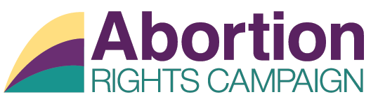

Subject Access Request Form

Request for Access to Personal Data under the General Data Protection Regulation 2018.

Note: Requests for personal data must be accompanied by proof of your identity, including a photocopy of your passport, or driving licence or Public Services Card, so that we can verify your identity.

Please complete all parts.

Part 1: Details of Data Subject (person making the request)

Contact Details:

Full Name:

Address:

Contact Phone Number:

Email Address (where applicable):

Part 2: Details of Request

To assist us in locating the data requested, please include details of your interactions with ARC in the past (e.g. please state the area(s) you have corresponded with / the types of applications you may have made etc.)

Please indicate the period of time for which the data is being sought.

Please outline details of the data sought.

Part 3: Verification of Identity
For us to verify your identity, please provide the following information
Provide a copy of photographic ID (Public services card/passport/drivers licence).

Part 4: Declaration

I declare that all the details I have provided in this form are true and complete to the best of my knowledge.
Signature of Requester

Date:

Please email a copy of this form to dpo@abortionrights.ie or post to Abortion Rights Campaign, 105 Capel Street, Dublin 1.

